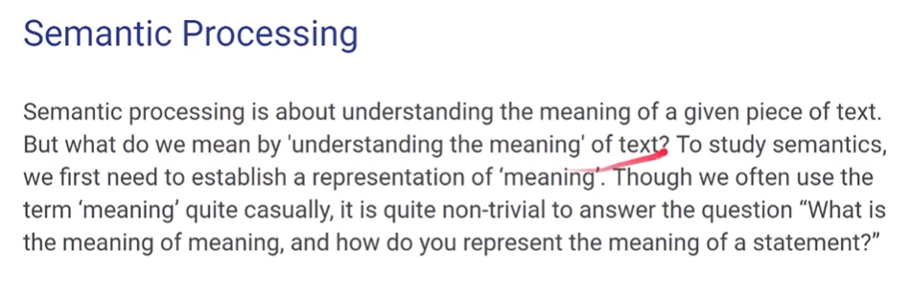

**Semantic analysis describes the process of understanding natural language–the way that humans communicate–based on meaning and contex**

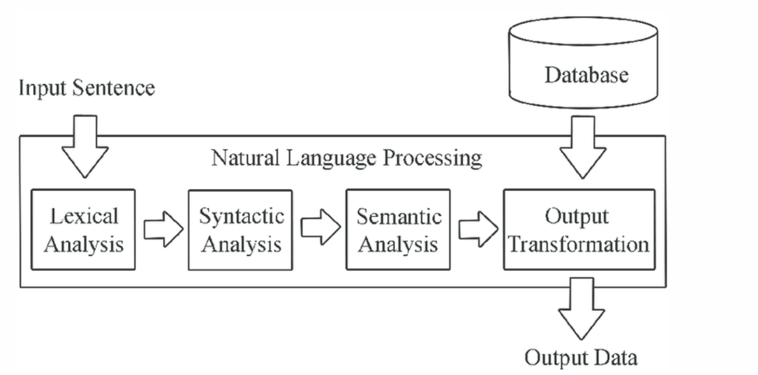

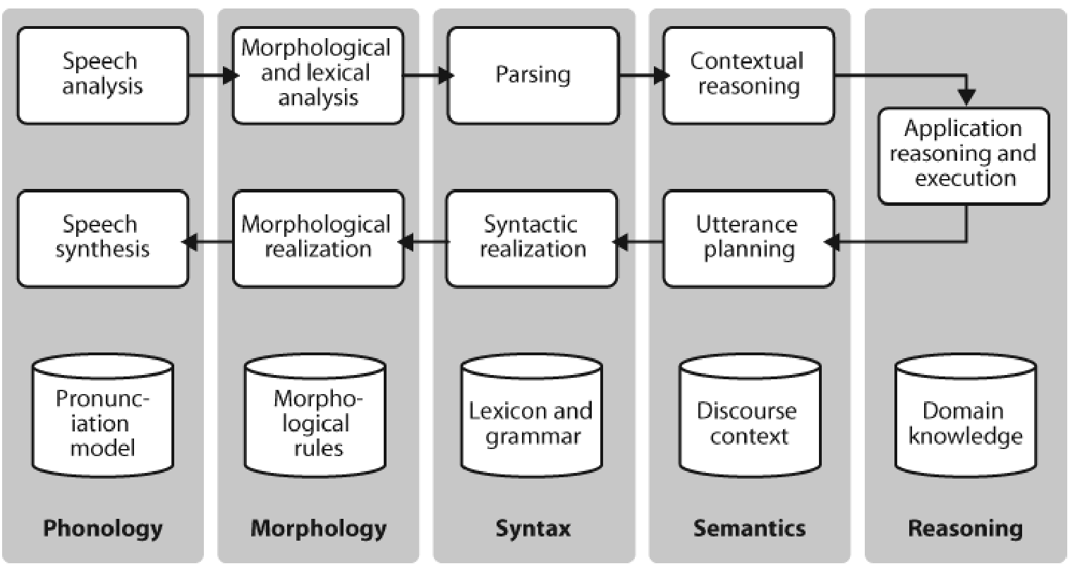

Semantic analysis is used in tools like

* machine translations
* chatbots
* search engines
* text analytics

**Types of Semantic associations:**

|  |  |
| --- | --- |
| **Hyponymy** | It illustrates the connection between a generic word and its occurrences  The generic term is known as **hypernym**  the occurrences are known as **hyponyms**  Hyponymy and hypernymy - YouTube |
| **Homonymy** | described as **words with the same spelling or form** but **diverse and unconnected meanings** |
| **Polysemy** | polysemy has the same spelling but various and related meanings |
| **Meronomy** | logical arrangement of letters and words indicating a component portion of or member of anything.  type of hierarchy that deals with part–whole relationships, in contrast to a taxonomy whose categorisation is based on discrete sets.  5.1a: A meronomy is a hierarchy that uses the composition relation. |  Download Scientific Diagram  Tree is **Holonym** of Root,trunk,branch and leaves  Roots are **Meronomy** of Tree  Computer is **holonym** of Operating System  Operating system is **meronomy** of Computer |
| **Antonymy** | relationship between two lexical items that include semantic components that are symmetric with respect to an axis |
| **Synonymy** | denotes the relationship between two lexical elements that have different forms but express the same or a similar meaning. |

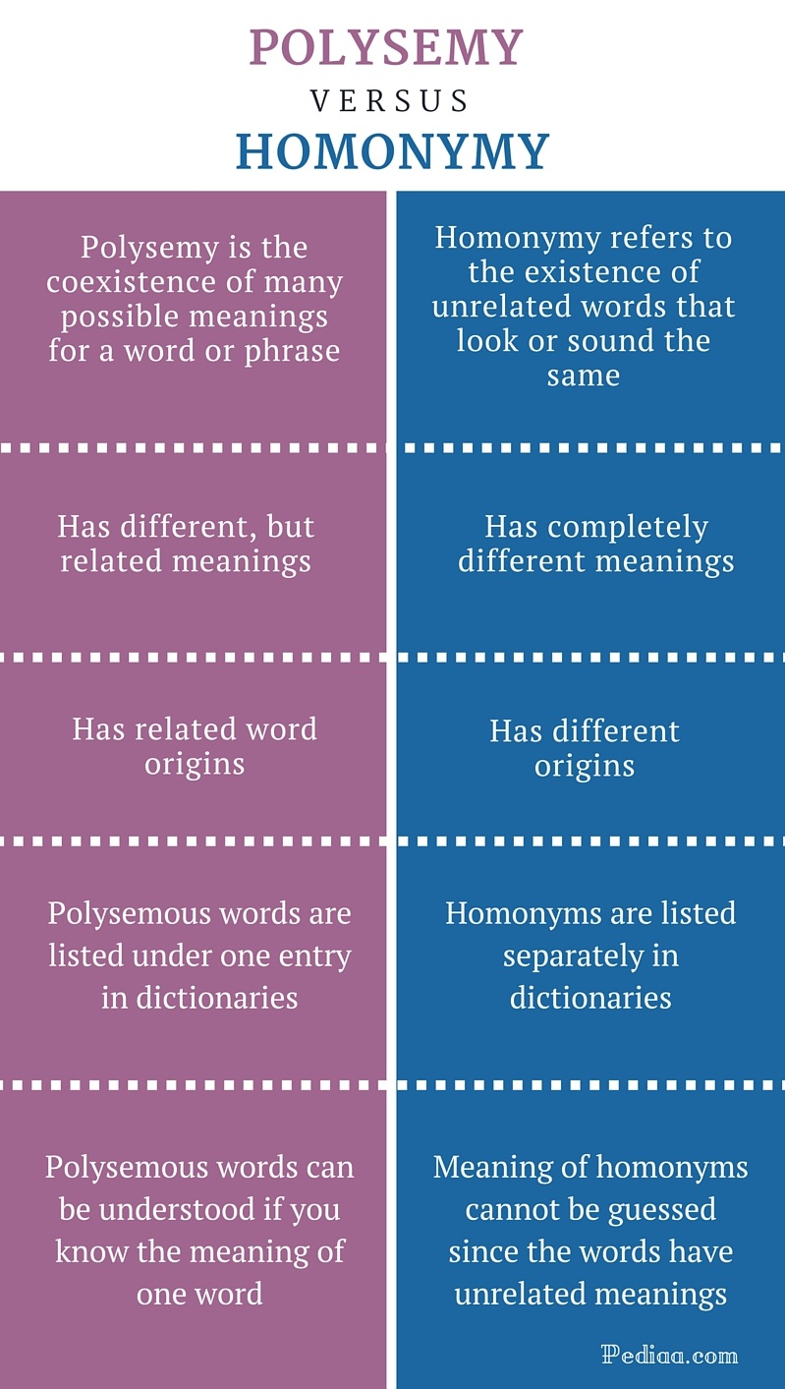

 Through identifying these relations and taking into account different symbols and punctuations, the machine is able to identify the context of any sentence or paragraph.

Through identifying these relations and taking into account different symbols and punctuations, the machine is able to identify the context of any sentence or paragraph.

**building blocks of the semantic system**

|  |  |
| --- | --- |
| **Entities** | Any **sentence is made of different entities that are related to each other**. It represents any individual category such as name, place, position, etc. |
| **Concepts** | **It represents the general category of individual, such as person, city etc** |
| **Relations** | **It represents the relation between different entities and concepts in a sentence** |
| **Predicates** | **It represents the verb structure of any sentence.** |

**different approaches to Meaning Representations**

* *First-order predicate logic (FOPL)*
* *Frames*
* *Semantic Nets*
* *Case Grammar*
* *Rule-based architecture*
* *Conceptual graphs*
* *Conceptual dependency (CD)*